**Homework 4 – DC Machines**

*This homework is to be solved using computational tools (such as MATLAB). A template is provided. You should submit your homework by converting your .m file solution (from the template) to pdf by using* ***publish*** *command. Required explanations and several tips are given in the template.*

**Q.1.** Consider the different types of electric motors shown in Figure 1. General torque expression of a machine is also given as follows:

Where i1 is the current of the stator coil, i2 is the current on rotor coil, L11 is the self-inductance of stator coil, L22 is the self-inductance of rotor coil, and L12 is the mutual inductance between the stator coil and rotor coil. Stator and rotor cores can be assumed as infinitely permeable.



**Motor-1 Motor-2**



**Motor-3 Motor-4**

Figure 1: Different types of electric motors

**For each motor**, answer the given questions ***qualitatively***. *To get full credit, you need to give analytical reasoning!*

1. Is L11 constant or varying with respect to θ?
2. Is L12 constant or varying with respect to θ?
3. Is L22 constant or varying with respect to θ?
4. Can this machine produce torque when only stator coil is excited (i2 = 0)?
5. Can this machine produce torque when only rotor coil is excited (i1 = 0)?
6. Can this machine produce torque when none of the coils are excited (i1 = i2 = 0)?

**Q.2.**Consider the electric bicycle which has a DC motor on it as shown in Figure 2.

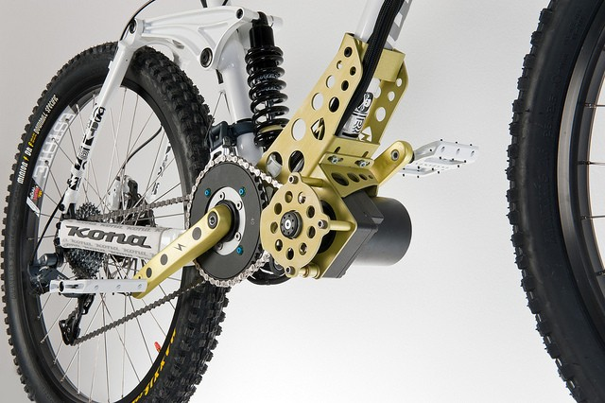 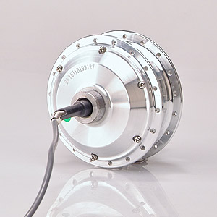

Figure 2: The electric bicycle and the DC motor

The motor drive system is shown in Figure 3 and specifications of the motor and other components are shown in Table 1.



Figure 3: The motor drive system

Table 1: Specifications of the motor and other components

|  |  |  |  |
| --- | --- | --- | --- |
| **DC Motor** | | **Bicycle** | |
| Rated Power | 350 W | Total Weight | 100 kg |
| Rated Voltage | 28 V | Wheel Diameter | 70 cm |
| Armature Resistance | 285 mΩ | Rated Speed | 30 km/h |
| Armature constant: Ka x ϕf | 1 V/(rad/s) | Super capacitor | 1000 F |

This bicycle will take part on a race the route of which is shown in Figure 4.

Figure 4: Bicycle race route

***Required explanations are given below:***

* The drag force acting on the bicycle has the following characteristics:

where Cd is the dimensionless drag coefficient (0.8), A is the front surface area (0.5 m2), ρ is the density of air (1.225 kg/m3) and v is the velocity of the bicycle (m/s).

* The force corresponding to the mechanical losses (road friction, rotational losses etc.) has the following characteristics:

where K is a coefficient (0.8 kg/s).

* The motor is coupled directly to the wheel. There is no gearbox.
* The field current is kept constant in all operating conditions at its rated value. The armature constant:

*K = Ka x ϕf = 1 V/(rad/s)*

* You can control the terminal voltage for the drive system. It is adjusted by the power electronics DC/DC converter which is fed from the super capacitor. The whole drive system can be considered as an ***adjustable, bidirectional*** *(current can flow in both directions)**and* ***bipolar*** *(voltage can be applied in both polarities)* ***DC power supply***.
* The desired operation during the race is shown in Figure 5. Until point B, the bicycle accelerates up to its rated speed with rated torque and it travels at constant speed until point G.



Figure 5: The desired operation (linear speed and motor torque) during the race

**Part I:** Calculate the following:

* Rated speed of the motor, in rad/sec.
* Rated torque of the motor, in Nm.
* Rated current of the motor, in Amps.

**Part II:** During the operation between B and C, calculate:

* The drag force, frictional force and net force acting on the bicycle, in N
* The torque of the motor (T2 in Fig.5), in Nm.
* The armature current, in Amps.
* The back emf, and the terminal voltage of the motor, in Volts.
* The efficiency of the motor.

**Part III:** During the operation between C and D (the bicycle climbs up the slope), calculate:

* The gravitational force, drag force and frictional force acting on the bicycle, in N.
* The torque of the motor (T1 in Fig.5), in Nm.
* The armature current, in Amps.
* The back emf, and the terminal voltage of the motor, in Volts.
* The efficiency of the motor.

**Part IV:** During the operation between E and F (the bicycle climbs down the slope), calculate:

* The gravitational force, drag force and frictional force acting on the bicycle, in N.
* The torque of the motor (T3 in Fig.5), in Nm.
* The armature current, in Amps.
* The back emf, and the terminal voltage of the motor, in Volts.
* The efficiency of the motor.

**Part V:**

1. Comment on the operation between A and B. How can the motor produce constant torque during the operation? What would happen if the rated terminal voltage is applied from the beginning?
2. Comment on the operation between B and C. What is the mode of operation?
3. Suppose that the capacitor voltage is 36V at point B and it takes 4 minutes to reach point C. What will the final capacitor voltage be (at point C)?
4. Comment on the operation between C and D. Is it wise to apply torque above rated? If you wanted to climb the bicycle at rated torque, what would you do?
5. Comment on the operation between E and F. What is the mode of operation?
6. Suppose that the capacitor voltage is 30V at point E and it takes 8 minutes to reach point F. What will the final capacitor voltage be (at point F)?